Tasks

1. Write a program to implement the membership package for different types of Membership.

Each membership has different benefits in terms of accommodation and Food.

You may choose to implement the abstract class or interface to achieve the same

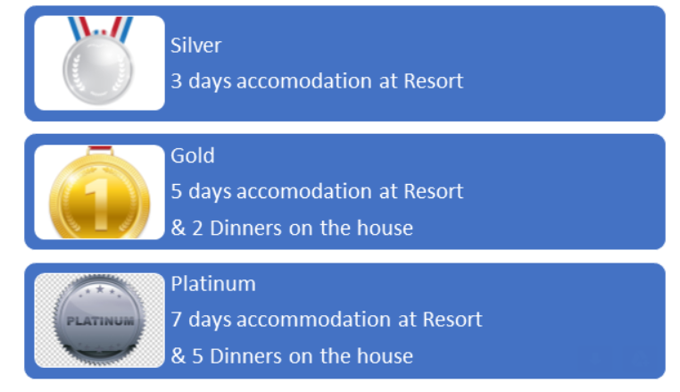

1. Write a class to have basic arithmetic operations add, sub, mul and div as abstract methods. Implement these methods in Calculator class.